Machine Learning
Field of study that gives computer the ability to learn without being explicitly programmed.

How Machine Learning Works:
In a machine learning project, we follow these steps:
1. Data Collection: First, we gather data that the computer will learn from.
2. Data Preprocessing: We clean and organize the data to make it suitable for training.
3. Model Selection: Next, we choose the right algorithm to train the computer.
4. Model Training: The computer learns from the data and adjusts itself to improve its performance.
5. Model Evaluation: We test the computer’s performance to see how well it learned.
6. Model Deployment: Finally, we use the trained computer to make predictions or decisions in real-world situations

Real-world Applications:
Machine learning has many practical uses in our lives, such as:
• Language Processing: It helps computers understand and respond to human language, like chatbots or language translation.
• Image Recognition: Computers can recognize objects or people in images, used in security or photo organization.
• Healthcare: ML aids doctors in diagnosing diseases and finding the best treatment options for patients.
• Finance: It’s used for detecting fraudulent activities in banking and making investment decisions.
• Recommendation Systems: ML suggests products, movies, or songs based on our interests and past behavior.
• Autonomous Vehicles: It enables self-driving cars to navigate safely on the roads.

Types of Machine Learning:
Machine learning can be divided into different types based on how computers
learn and the type of data they use.

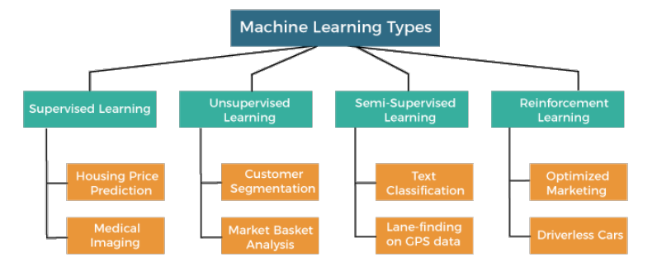

- Supervised Learning:
Supervised learning is like having a teacher guide the computer. The computer learns from labelled data, which means the input data and the correct output are given together. It uses this labelled data to make predictions on new, unseen data. For example, if we want the computer to recognize pictures of cats and dogs, we show it many pictures of cats labelled ”cat” and dogs labelled ”dog.” The computer learns to differentiate between cats and dogs and can predict the correct label for new images.
- Unsupervised Learning:
Unsupervised learning doesn’t have a teacher; the computer learns by itself. It deals with unlabelled data, where the computer tries to find patterns or structures in the data without any predefined categories. Clustering is a common unsupervised learning technique. For instance, if we give the computer a bunch of different animals’ pictures without labels, it may group similar animals together, even though it doesn’t know their names.

- Semi-supervised Learning:
Semi-supervised learning is a mix of supervised and unsupervised learning. Here, the computer uses both labelled and unlabelled data to learn. In some cases, getting labelled data can be expensive or time-consuming, so using a combination of labelled and unlabelled data can be more practical.
- Reinforcement Learning:
Reinforcement learning is like training a pet. The computer learns by taking actions in an environment and receiving rewards or penalties based on its actions. It aims to find the best actions that lead to the most rewards. For example, in a game, the computer may try different moves and learn which moves give it higher scores.

Python’s Ecosystem for ML :
Python’s ecosystem is enriched with several powerful libraries that simplify and accelerate machine learning development.

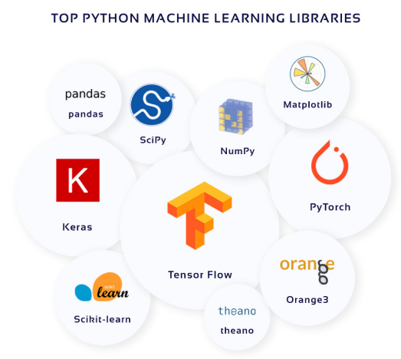

Classification and Regression:
In machine learning, two common types of tasks are classification and regression. Let’s explore each of them:

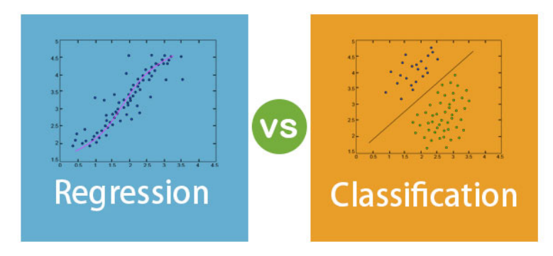
- Classification Techniques:
Classification is used to predict the category or class of a given input data point. The output of a classification model is discrete and belongs to a predefined set of classes.
- Regression Techniques:
Regression is used when the output we want to predict is a continuous value rather than a category. In regression, the model learns to map input data to a continuous output.

Training a Machine Learning Model:
Training a machine learning model is the process of teaching the computer to make predictions based on the provided data. In this section, we’ll go through the steps involved in training a model:
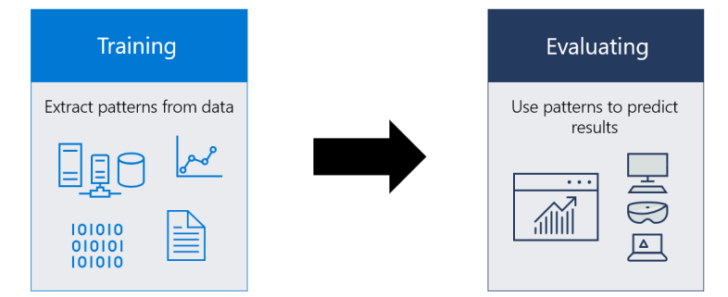

Data Preprocessing:
Before training a model, we need to prepare the data for effective learning. Data preprocessing involves several essential steps:
• Data Cleaning: We check for missing or inconsistent data and handle them appropriately. Cleaning ensures that the data is reliable and accurate.
• Feature Scaling: Features in the data may have different scales. Feature scaling brings all features to a similar scale, avoiding bias towards certain features during training.
• Feature Engineering: Sometimes, existing features may not be sufficient for accurate predictions. Feature engineering involves creating new features or extracting useful information from existing ones to improve model performance.

Splitting Data into Training and Testing Sets:
To evaluate the model’s performance, we split the data into two sets: the training set and the testing set. The training set is used to train the model, while the testing set is used to assess how well the model generalizes to new, unseen data. A common split ratio is 70-30 or 80-20.

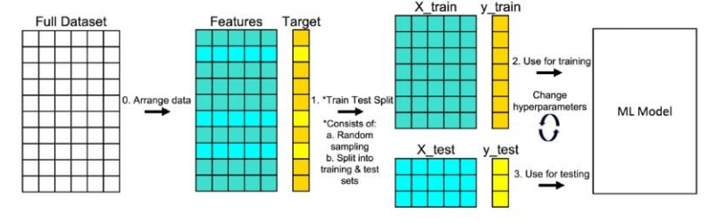

Model Selection and Evaluation:
Choosing the right model for the task is crucial. We select an appropriate algorithm based on the problem type (classification or regression) and the characteristics of the data. After training, we evaluate the model’s performance using various evaluation metrics like accuracy, precision, recall, F1-score, and more. Cross-validation helps in better estimating the model’s performance and prevents overfitting.

Linear Regression Algorithm:
Linear regression is one of the simplest regression algorithms. It fits a straight line to the data points, aiming to minimize the difference between the predicted and actual values.
Notation:
M -> Number of training examples.
X’s -> Input Variables/features.
Y’s -> Output Variable / ‘target’ variable.
(x,y) -> Single training example.
(xi,yi) -> ith training example (i is the index).
Steps:
- Take the training set.
- Pass it into the learning algorithm.
- Algorithm outputs a function (denoted by h).
- Function takes in an input (x).
- Tries to output the estimated value (y).

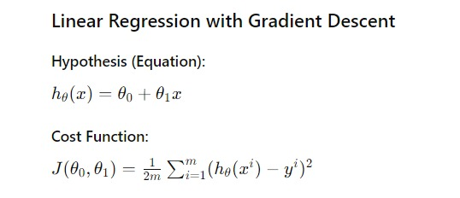

- 1/m determines the average of the squared difference.
- Finding the best θ0 and θ1 values which gives the least value for the cost function that set of θ0 & θ1 values will become the best fit parameters.

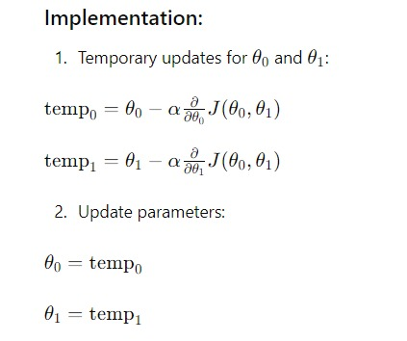

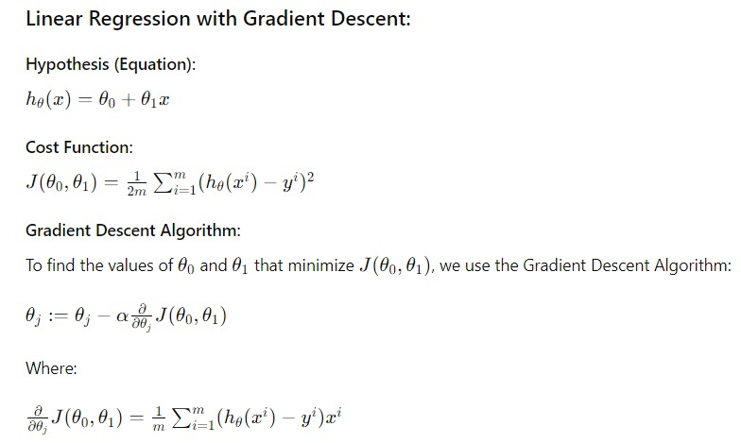
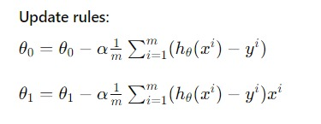
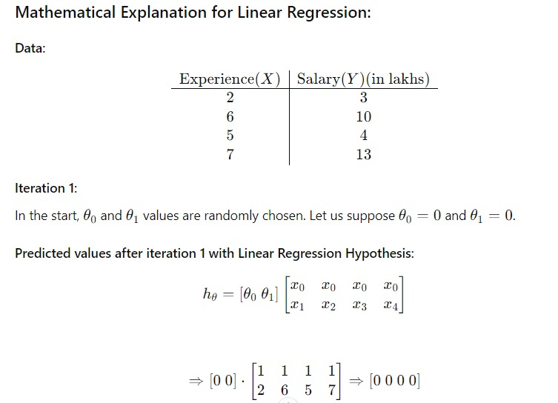
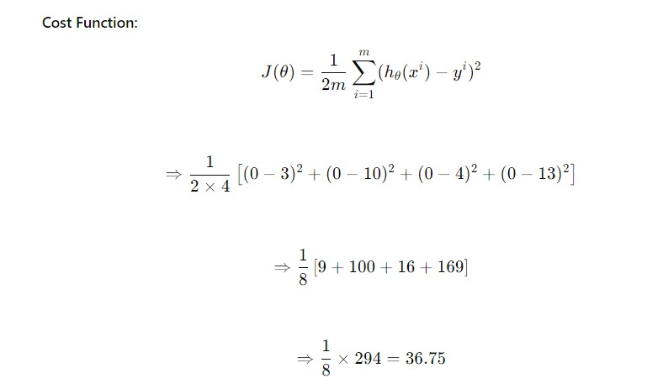
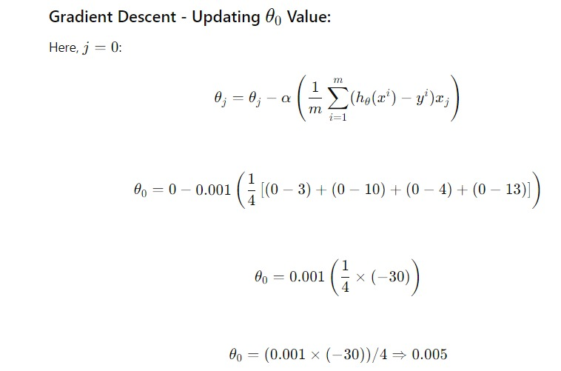
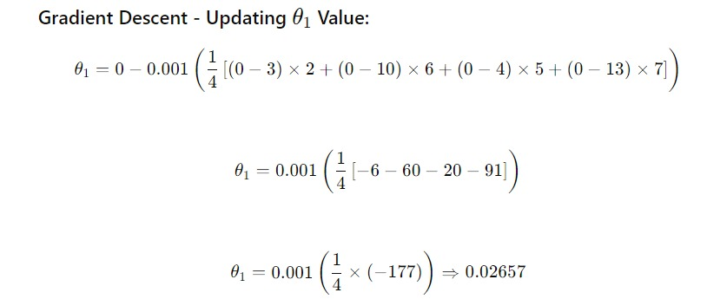
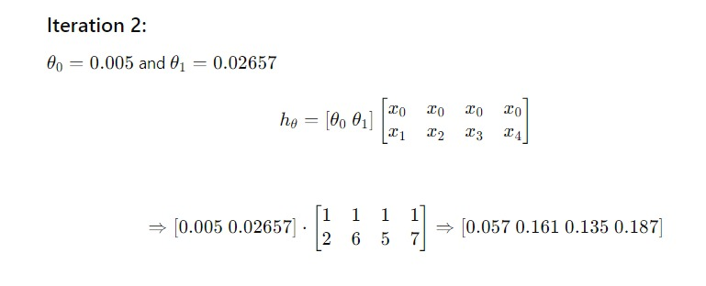
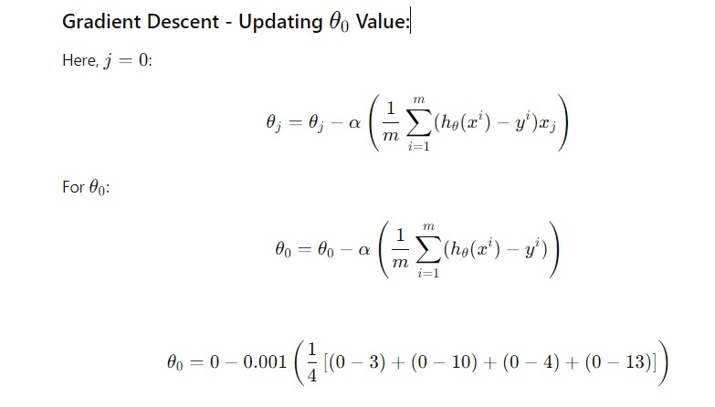
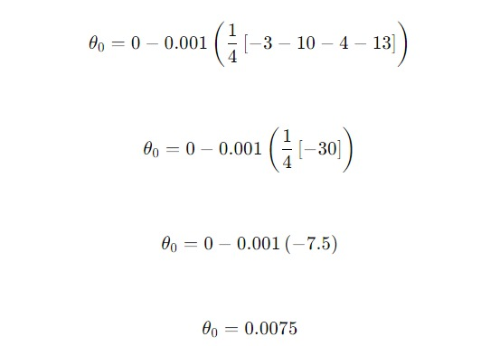
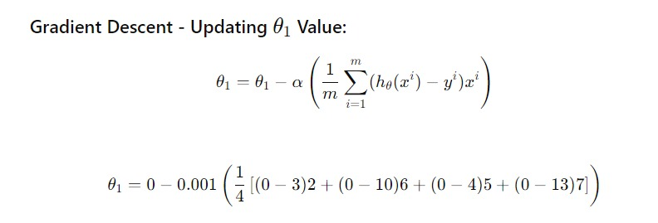

Now, similar to iteration no:1 performed above we will again calculate Cost Function & update θj values using Gradient Descent. We will keep on iterating until the Cost Function does not reduce further.

Implementation in Python:
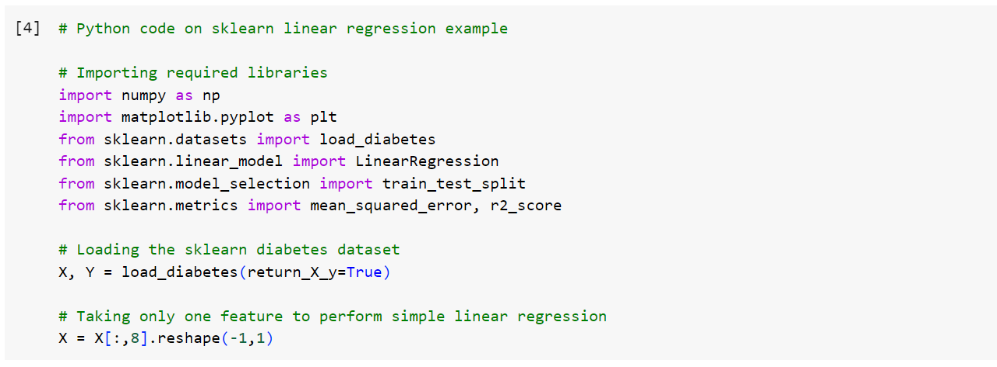
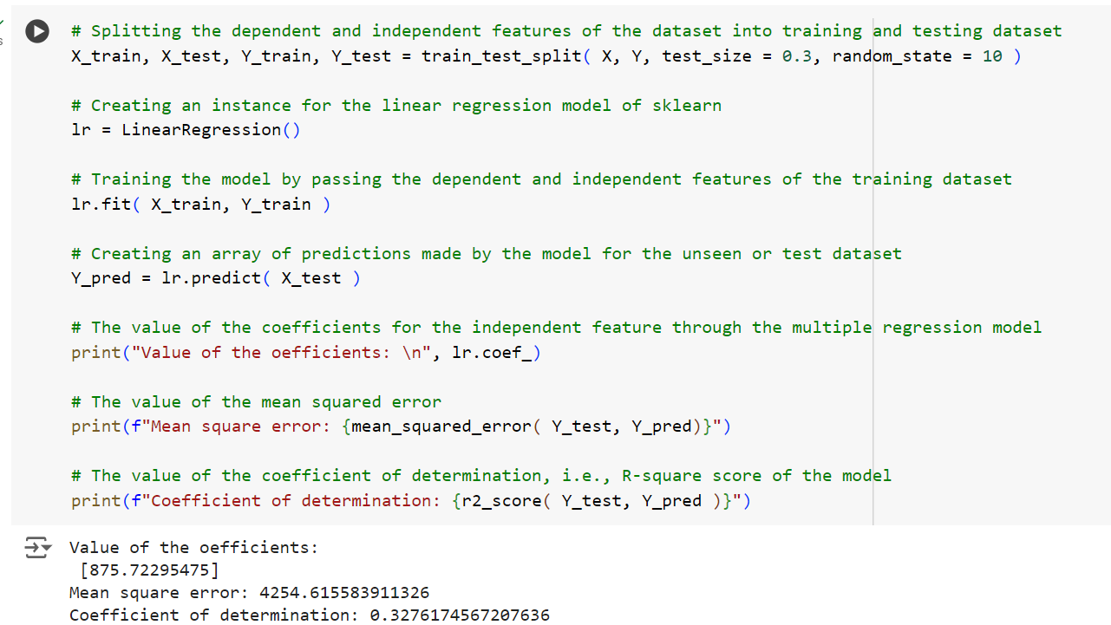
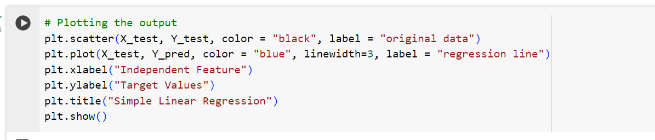
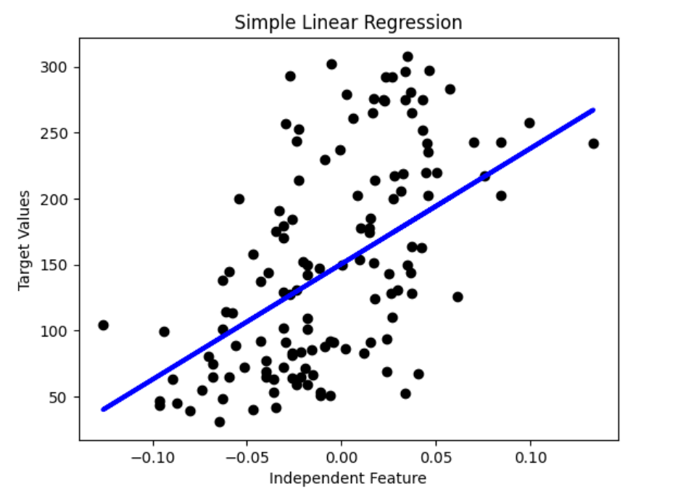
Advantages | Disadvantages
Simple to implement and easy to interpret the output coefficients. | Outliers can have huge effect on the regression.
Best algorithm when there is a linear relation between the dependent and independent variables. | Can only be preferred if there’s a between the dependent and independent variables.
Although Linear Regression is susceptible to overfitting this can be avoided by Regularization. | Linear Regression looks only at the relationship between the mean of dependent and independent variables.

K-Mean Clustering Algorithm:
K-Means Clustering is an Unsupervised Machine Learning algorithm, which groups the unlabelled dataset into different clusters. K-means clustering is a method that assigns data points to one of 𝐾 clusters based on their distance from the cluster centroids. Initially, the centroids are randomly assigned within the data space. Each data point is then assigned to the nearest cluster based on the distance to the centroid. Once all data points are assigned, new centroids are computed. This iterative process continues until the clusters stabilize, resulting in an optimal clustering configuration. In this analysis, we assume that the number of clusters, 𝐾, is predetermined, and our objective is to allocate data points to these clusters.
In certain situations, the optimal value of 𝐾 may not be apparent, necessitating additional consideration to determine it. K-means clustering is most effective when data points are well-separated. However, it is less suitable for overlapping data points. Compared to other clustering techniques, K-means is faster and provides a strong coupling between data points and clusters. However, it does not offer clear insights into the quality of the clusters. Different initial centroid assignments can result in varying clusters, and the algorithm is sensitive to noise, potentially leading to convergence in local minima.
The above algorithm in pseudocode is as follows:
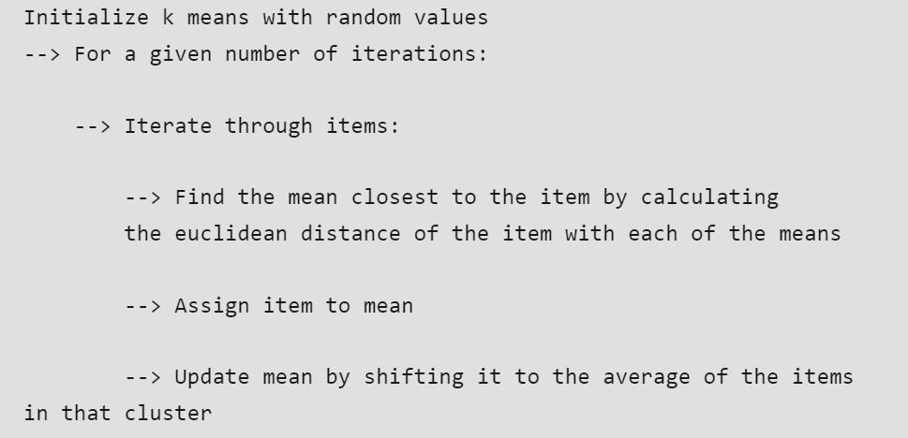
Implementation in Python:
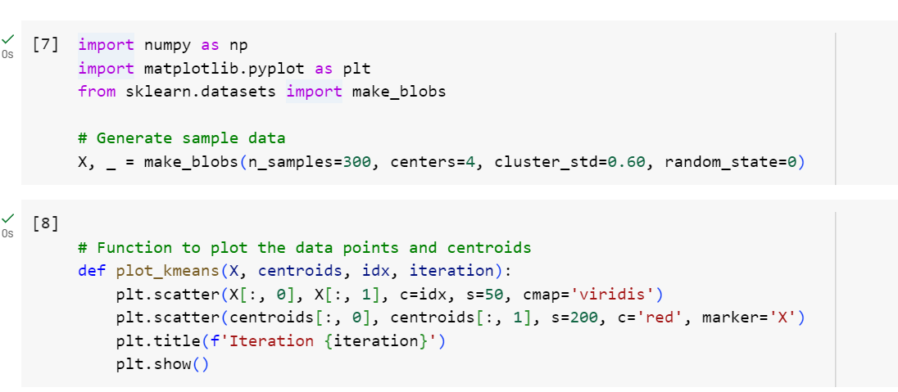
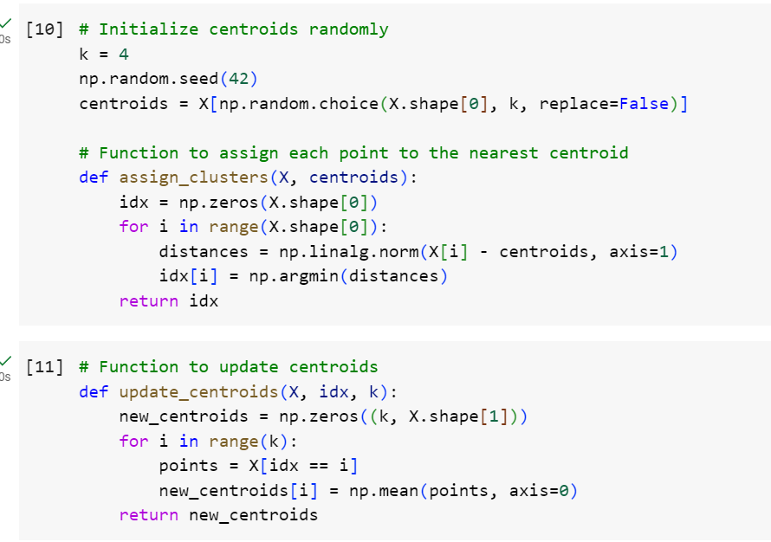
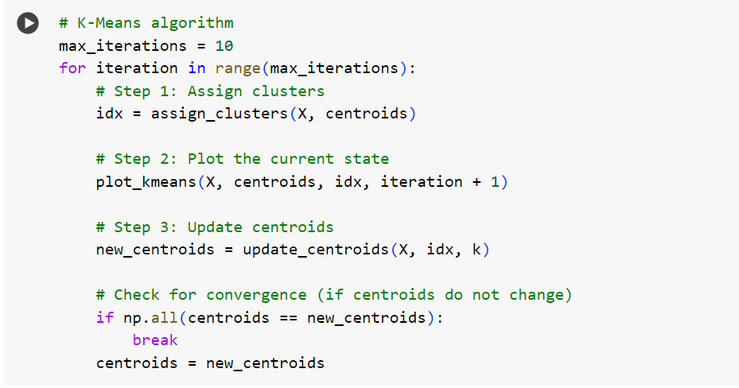
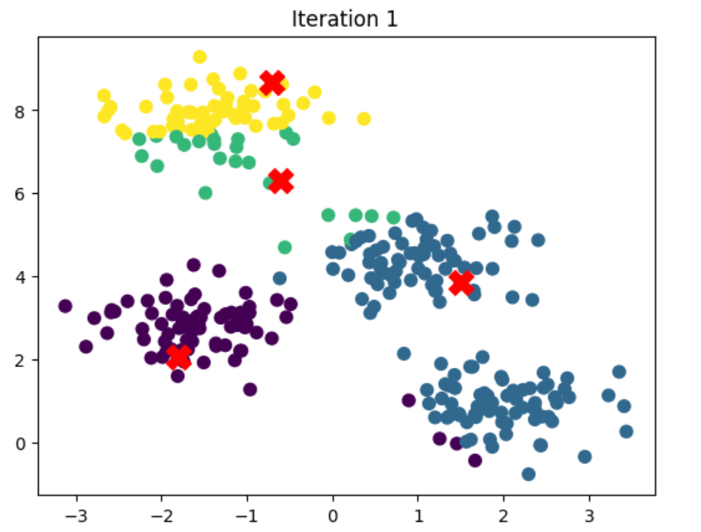
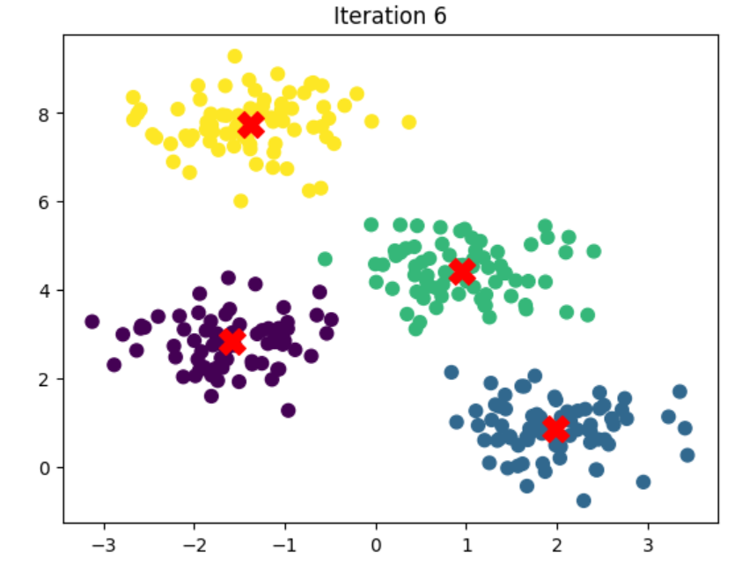
Advantages of K-Means:
- Relatively simple to implement.
- Scales to large data sets.
- Guarantees convergence.
- Can warm-start the positions of centroids.
- Easily adapts to new examples.
- Generalizes to clusters of different shapes and sizes, such as elliptical clusters.
Disadvantages of K-Means:
- Choosing 'k' manually.
- Being dependent on initial values.
- Clustering data of varying sizes and density.
- Clustering outliers.

KNN (K-Nearest Neighbours) Algorithm:
K-Nearest Neighbours (KNN) is a simple and intuitive algorithm used for both classification and regression tasks. It is a type of supervised learning algorithm where the data points are classified based on the majority class among their nearest neighbours.

Workings of KNN algorithm:
Thе K-Nearest Neighbours (KNN) algorithm operates on the principle of similarity, where it predicts the label or value of a new data point by considering the labels or values of its K nearest neighbours in the training dataset.
Step-by-Step explanation of how KNN works is discussed below:
Step 1 - Selecting the optimal value of K:
- K represents the number of nearest neighbours that needs to be considered while making prediction.
Step 2 - Calculating distance:
- To measure the similarity between target and training data points, Euclidean distance is used.
- Distance is calculated between each of the data points in the dataset and target point.
Step 3 - Finding Nearest Neighbours:
- The k data points with the smallest distances to the target point are the nearest neighbours.
Step 4 - Voting for Classification or Taking Average for Regression:
- In the classification problem, the class labels of K-nearest neighbours are determined by performing majority voting. The class with the most occurrences among the neighbours becomes the predicted class for the target data point.
- In the regression problem, the class label is calculated by taking average of the target values of K nearest neighbours. The calculated average value becomes the predicted output for the target data point.
Distance Metrics Used in KNN Algorithm:
Euclidean Distance: This is nothing but the cartesian distance between the two points which are in the plane/hyperplane.
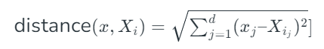
Manhattan Distance: Manhattan Distance metric is generally used when we are interested in the total distance travelled by the object instead of the displacement.
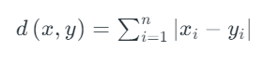
Minkowski Distance: We can say that the Euclidean, as well as the Manhattan distance, are special cases of the Minkowski distance.
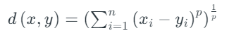
Implementation in Python:
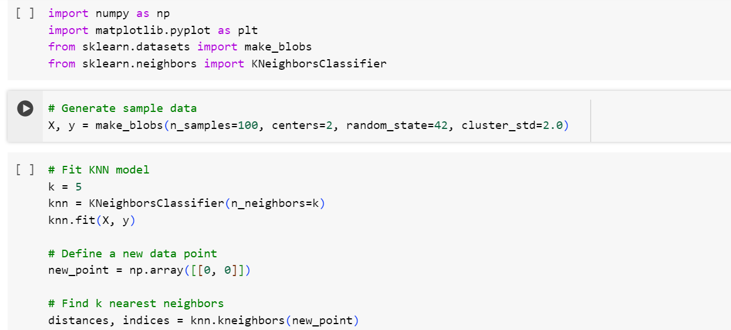
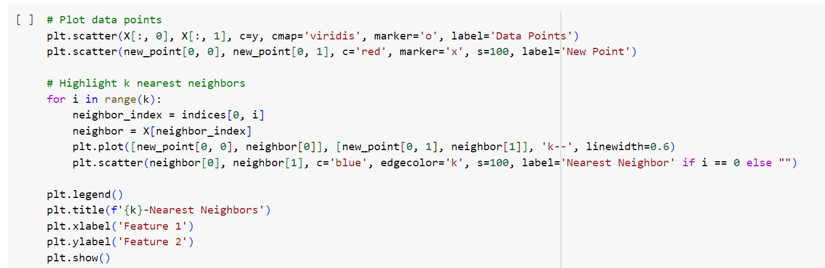
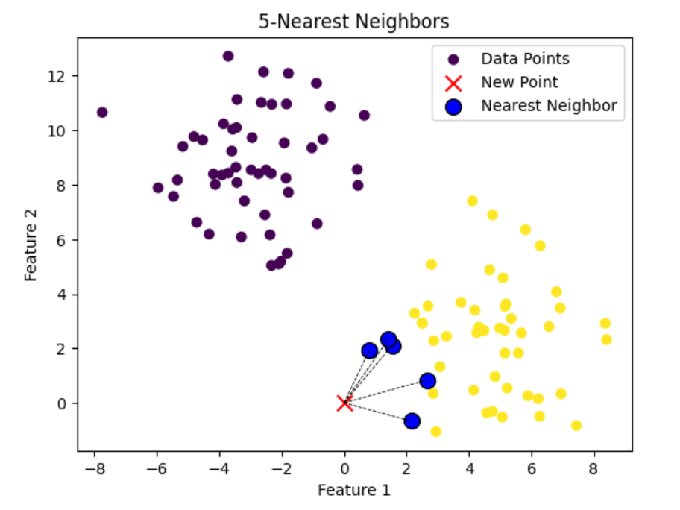

Advantages of the KNN Algorithm
- Simple Implementation: The KNN algorithm is straightforward to implement due to its low complexity.
- Adaptive Nature: KNN stores all data points in memory. When new data points are added, the algorithm automatically adjusts to incorporate them in future predictions.
- Few Hyperparameters: Training a KNN model requires only the value of 𝑘 and the choice of distance metric.
Disadvantages of the KNN Algorithm

- Scalability Issues: KNN is a lazy algorithm, meaning it requires significant computing power and data storage, making it time-consuming and resource-intensive.
- Curse of Dimensionality: KNN struggles with high-dimensional data, making it difficult to classify data points accurately in such cases.
- Prone to Overfitting: Due to the curse of dimensionality, KNN is susceptible to overfitting. Techniques such as feature selection and dimensionality reduction are often applied to mitigate this issue.

Decision Trees:
Decision trees are a type of supervised learning algorithm used in machine learning. They are used for classification and regression analysis. Decision trees use a tree-like structure of nodes, branches, and leaves to model decisions and their consequences. Decision trees are non-parametric, which means they do not make any assumptions about the distribution of the data.
- Root Node: It represents the entire population or sample, and this further gets divided into two or more homogeneous sets.
- Branches (Edges): Links between nodes that show how decisions are made in response to particular circumstances.
- Leaf/ Terminal Node: A node that cannot be split further is called Leaf or Terminal node. Decision Node: When a sub-node splits into further sub-nodes, then it is called a decision node.
- Branch / Sub-Tree: A subsection of the entire tree is called a branch or sub-tree.
- Parent and Child Node: A node, which is divided into sub-nodes, is called the parent node of sub-nodes, whereas sub-nodes are the child of the parent node.
- Splitting: It is a process of dividing a node into two or more sub-nodes.
- Parent Node: A node that is split into child nodes. The original node from which a split originates.
- Child Node: Nodes created as a result of a split from a parent node.
- Decision Criterion: The rule or condition used to determine how the data should be split at a decision node. It involves comparing feature values against a threshold.
- Pruning: Pruning is when we selectively remove branches from a tree. The goal is to remove unwanted branches, improve the tree’s structure, and direct new, healthy growth.
- Impurity: In decision trees, impurity is a measure of the homogeneity of the labels at the node. The current implementation provides two impurity measures for classification (Gini impurity and entropy) and one impurity measure for regression (variance). The algorithm chooses the partition maximizing the purity of the split (i.e., minimizing the impurity).
Example:
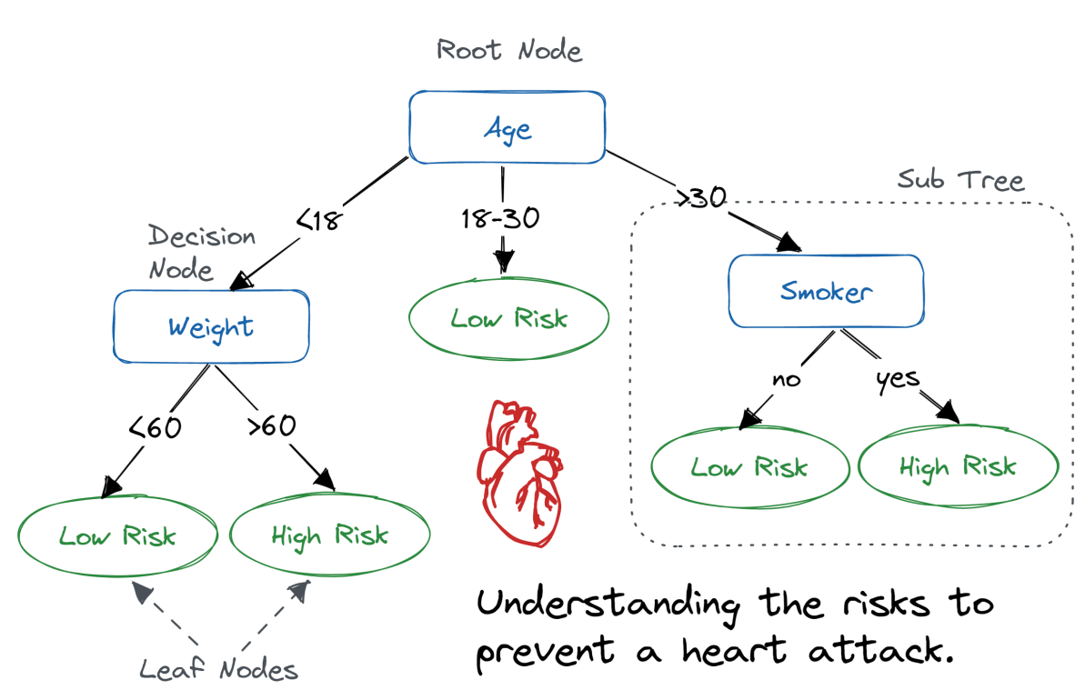

How Decision Tree is formed?:
The process of forming a decision tree involves recursively partitioning the data based on the values of different attributes. The algorithm selects the best attribute to split the data at each internal node, based on certain criteria such as information gain or Gini impurity. This splitting process continues until a stopping criterion is met, such as reaching a maximum depth or having a minimum number of instances in a leaf node.
In the Decision Tree, the major challenge is the identification of the attribute for the root node at each level. This process is known as attribute selection. We have two popular attribute selection measures:
- Information Gain
- Gini Index
1. Information Gain:
When we use a node in a decision tree to partition the training instances into smaller subsets the entropy changes. Information gain is a measure of this change in entropy.
Suppose S is a set of instances,
A is an attribute
Sv is the subset of S
v represents an individual value that the attribute A can take and Values (A) is the set of all possible values of A, then
Entropy: is the measure of uncertainty of a random variable, it characterizes the impurity of an arbitrary collection of examples. The higher the entropy more the information content.
2. Gini Index:
Gini Index is a metric to measure how often a randomly chosen element would be incorrectly identified.
- It means an attribute with a lower Gini index should be preferred.
- Sklearn supports “Gini” criteria for Gini Index and by default, it takes “gini” value.
- The Formula for the calculation of the Gini Index is given below.
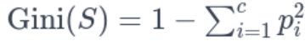
Implementation in Python:
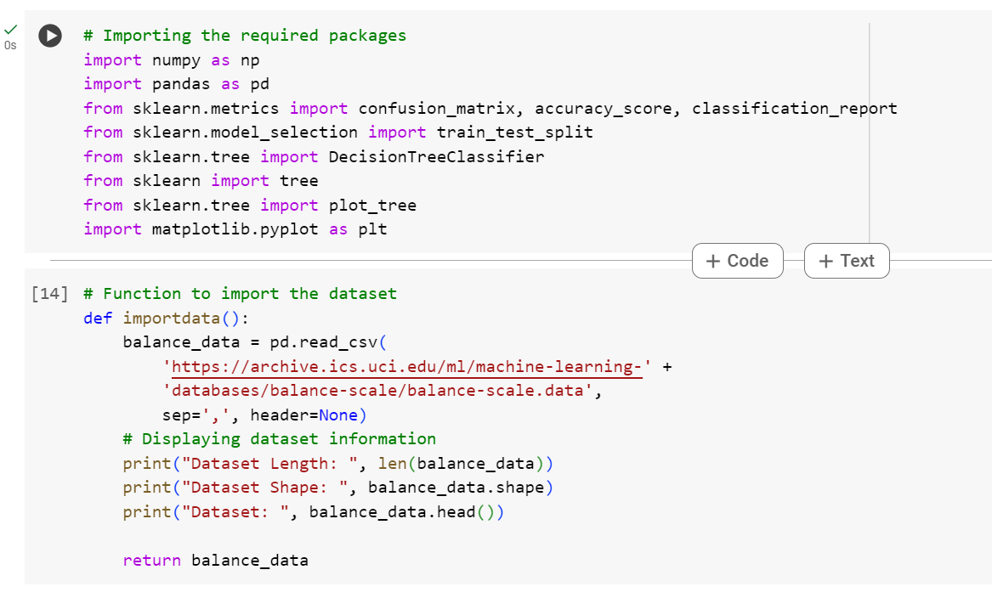
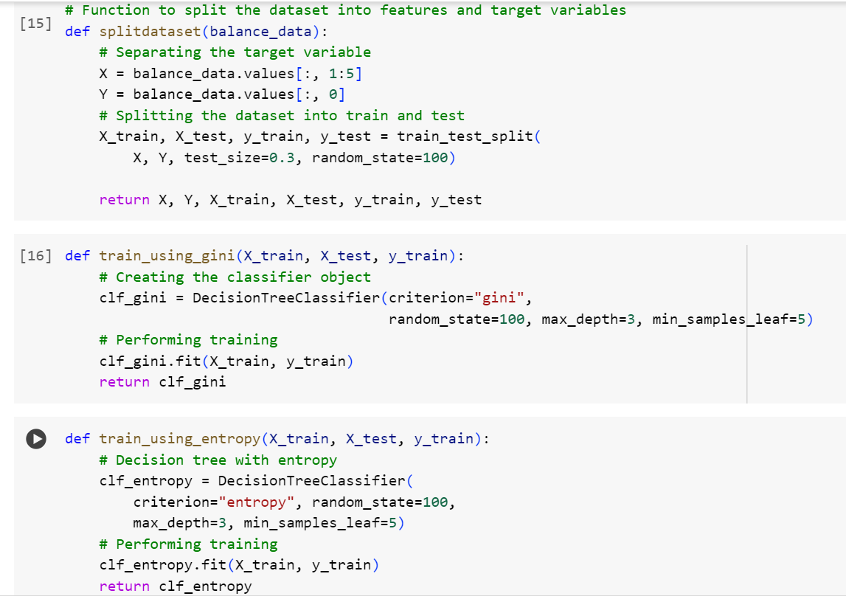
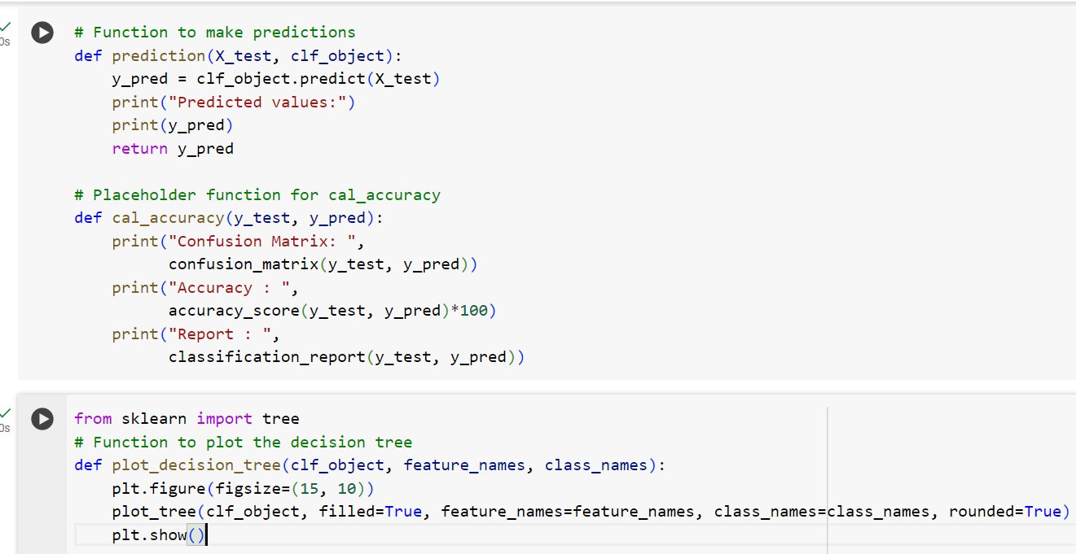
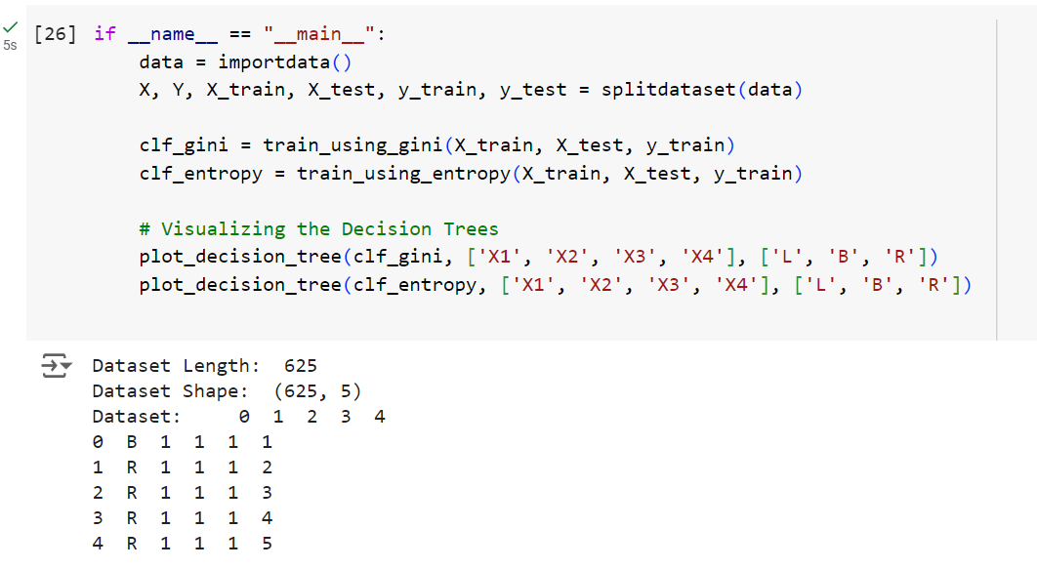
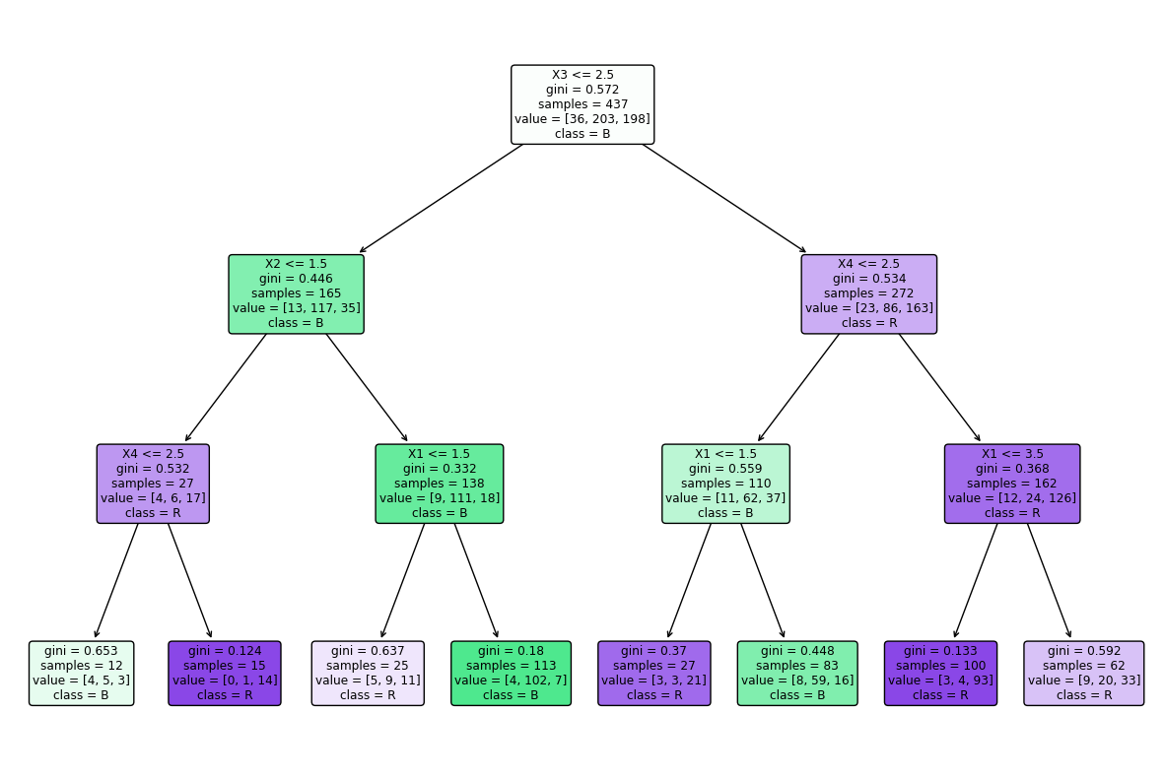
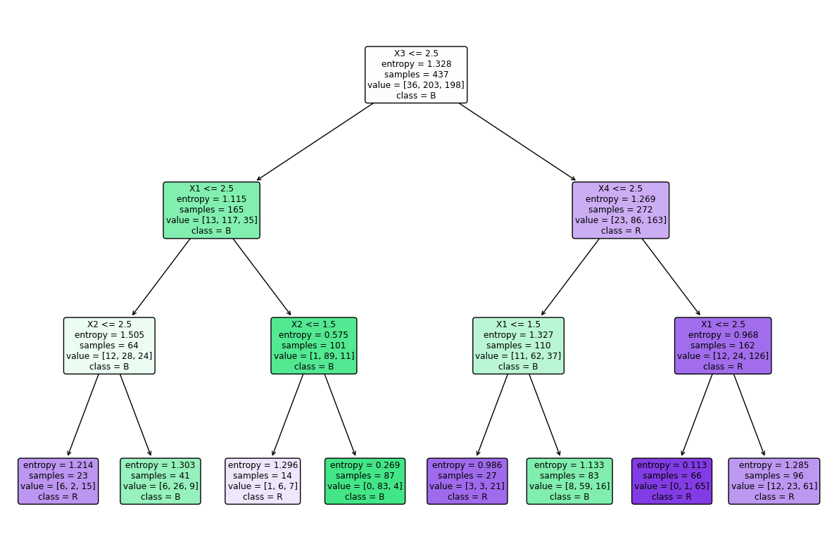

Advantages of Decision Tree:
- Easy to understand and interpret, making them accessible to non-experts.
- Handle both numerical and categorical data without requiring extensive preprocessing.
- Provides insights into feature importance for decision-making.
- Handle missing values and outliers without significant impact.
- Applicable to both classification and regression tasks.
Disadvantages of Decision Tree:
- Disadvantages include the potential for overfitting
- Sensitivity to small changes in data, limited generalization if training data is not representative
- Potential bias in the presence of imbalanced data.

Support Vector Machine:
Support Vector Machine (SVM) is a powerful algorithm used for classification tasks. It helps us draw a line (or a boundary) between different groups of data points.
How SVM Works:
Imagine we have two groups of data points on a 2D graph, like blue circles and red crosses. SVM tries to find the best line that separates these two groups with the biggest gap (margin) between them. This line is called the ”decision boundary.” The data points closest to the decision boundary are called ”support vectors.” These support vectors help us define the boundary between the groups.
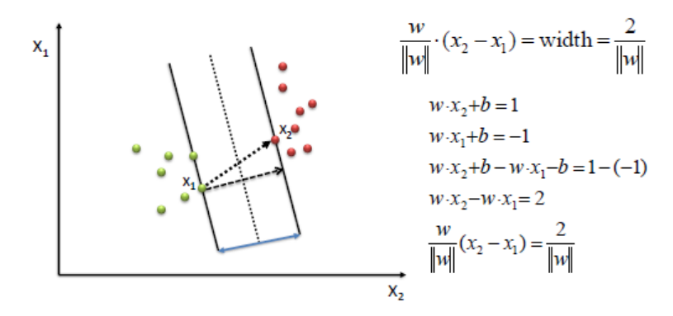
When Data is Not Separable:
Sometimes, the data points are not easily separable with a straight line. In such cases, SVM uses a trick called ”kernel” to transform the data into a higher-dimensional space where it can find a separating boundary.
- Hyperplane: Hyperplane is the decision boundary that is used to separate the data points of different classes in a feature space. In the case of linear classifications, it will be a linear equation i.e. wx+b = 0.
- Support Vectors: Support vectors are the closest data points to the hyperplane, which makes a critical role in deciding the hyperplane and margin.
- Margin: Margin is the distance between the support vector and hyperplane. The main objective of the support vector machine algorithm is to maximize the margin. The wider margin indicates better classification performance.
- Kernel: Kernel is the mathematical function, which is used in SVM to map the original input data points into high-dimensional feature spaces, so, that the hyperplane can be easily found out even if the data points are not linearly separable in the original input space. Some of the common kernel functions are linear, polynomial, radial basis function(RBF), and sigmoid.
- Hard Margin: The maximum-margin hyperplane or the hard margin hyperplane is a hyperplane that properly separates the data points of different categories without any misclassifications.
- Soft Margin: When the data is not perfectly separable or contains outliers, SVM permits a soft margin technique. Each data point has a slack variable introduced by the soft-margin SVM formulation, which softens the strict margin requirement and permits certain misclassifications or violations. It discovers a compromise between increasing the margin and reducing violations.
- C: Margin maximisation and misclassification fines are balanced by the regularisation parameter C in SVM. The penalty for going over the margin or misclassifying data items is decided by it. A stricter penalty is imposed with a greater value of C, which results in a smaller margin and perhaps fewer misclassifications.
- Hinge Loss: A typical loss function in SVMs is hinge loss. It punishes incorrect classifications or margin violations. The objective function in SVM is frequently formed by combining it with the regularisation term.
- Dual Problem: A dual Problem of the optimisation problem that requires locating the Lagrange multipliers related to the support vectors can be used to solve SVM. The dual formulation enables the use of kernel tricks and more effective computing.
Mathematical intuition of Support Vector Machine:
Consider a binary classification problem with two classes, labelled as +1 and -1. We have a training dataset consisting of input feature vectors X and their corresponding class labels Y.
The equation for the linear hyperplane can be written as:
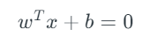
The vector W represents the normal vector to the hyperplane. i.e the direction perpendicular to the hyperplane. The parameter b in the equation represents the offset or distance of the hyperplane from the origin along the normal vector w.
The distance between a data point x_i and the decision boundary can be calculated as:
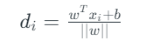
where ||w|| represents the Euclidean norm of the weight vector w. Euclidean norm of the normal vector W
For Linear SVM classifier:
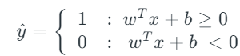
Implementation in python:
